Construction Blockchain 2023 Research/Presentation Title
Subtitles (are not captured)

1ST GIVEN NAME SURNAME¹, ¹Dept. name of organization (of Affiliation), City, ¹email@address.com or ORCID

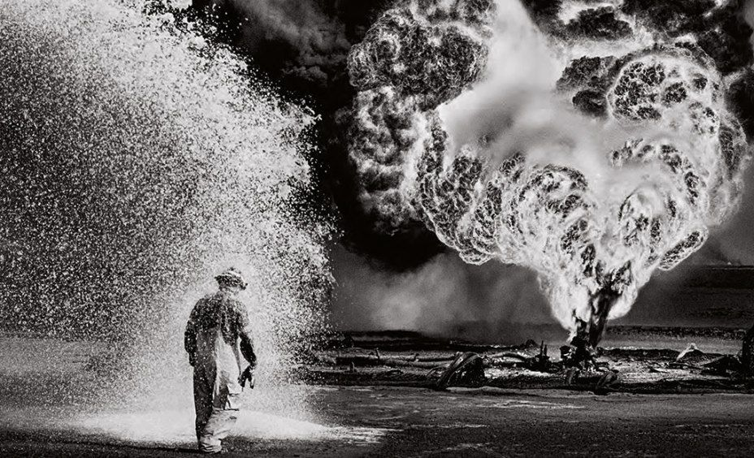

- Editorial image – 300dpi to 600dpi (figure caption). A key image that invokes you opinion or sythesis

A good editorial is an opinion maker. If it is based on evidence, so much the better. It analyses evidence rather than produces it. Of course, what it analyses can be the basis of the production of new evidence, but it is more like the ‘Results and Discussion’ that follow ‘Materials and Method’ in a research paper in so far as it is an objective analysis. However, it goes beyond an analysis. It must necessarily also express an opinion. It must attempt to critically analyse and sift from the various opinions, analyses and evidence floating around. It must present a refreshing perspective on an issue so as to retain balance when writings get opinionated; and/or stir up the crotchety and crusty when scientific/creative stupor sets in. Moreover, a good editorial is contemporary without being populist. It tackles recent events and issues and attempts to formulate viewpoints based on an objective analysis of happenings and conflicting/contrary opinions.
An editorial is predominantly about balance, but that does not prevent it from occasionally stirring things up, when such is the need. Hence a hard-hitting editorial is as legitimate as a balanced equipoise that reconciles apparently conflicting positions and controversial posturing, whether amongst politicians (in newspapers), or amongst researchers (in academic journals).
All said and done, the element of balance can never be lost. For that, it certainly helps if an editor is a balanced individual by temperament as well. However, let it not mean that balance in temperament excludes crusading zeal. Most editors of some merit have the latter in reasonable quantity, although they may play it down, or publicly make a mockery of it, since it is the in thing to do (the mockery, not the crusading). Moreover, denial can be a strong defence mechanism, as much in editors as in the rest of humanity.

About Design Algorithms
The CBC 2021 conference is organized into three main themes. At the core of the conference is the theme of Algorithms. This is further studied from a contextual perspective as the activity generating Cultures of computational design and, from the natural sciences perspective, as the activities encoding Cognitions of computational design.
The themes of Algorithms, Cultures, and Cognitions guide the peer-review process and workstreams of the conference.

About Design Cultures of Practice
Consider and elaborate on how computational design is changing in your particular domain of practice and design practices and cultures in general.

About Design Cognitions
Consider and elaborate on how computational design is affecting the human conceptualization and perceptions of design. How it is transforming the cognitive and psychological processes information and navigation of design.

Summing up & Effect
Like the dessert after a good meal leaves an, in fact decides the, after taste, a good editorial must also be careful to leave a good after taste. This is one in which the reader is held to the piece and retains his interest right till the end. So the piece has to be sufficiently brief to hold his attention, and equally entertaining to hold his attention so that the wholesome is imbibed. It must be such that the reader feels enlightened, or empowered, or helped in forming his own opinion on an issue. While a good editorial expresses an opinion, it does not force it down the throat of the reader. It is subtle enough to appeal to the good sense of the knowledgeable reader without forcing him to toe its line. This is its real test.
The feeling after a good editorial is done with is one of profundity. It is of being in the presence of an enlightened being. It is of feeling ennobled and charged to do something worthwhile or feel reconciled from a knotty or vexing thought process. It must, moreover, want you to give it a second read. Like wanting a second helping of a good dessert. And want to read further editorials by the same author. Like wanting ones favourite dessert after a meal.
Be sure to adhere to the word limitation (2 to 3 pages maximum). These directions are written in the format required for the abstract of the paper for the Design Computation Conference. We recommend that you use the MS Word document text formatting and use it as the template for your abstract as it contains all necessary formats and styles.
For more detailed information about conference submission, please refer to the DCWiki page on the CBC 2021:
- http://wiki.designcomputation.org/home/index.php/DC_I/O_Conference

Refernces
CBC 2021 uses Harvard (no abbreviations) within square brackets [Eason et al. 1955]. The sentence punctuation follows the bracket [Strunk and White 1999]. Refer simply to the reference, as in [Shalunts 2015] - do not use “Ref. [Shalunts 2015]” or “reference ”.
Number footnotes separately in superscripts. Place the actual footnote at the bottom of the column in which it was cited. Do not put footnotes in the abstract or reference list. Use letters for table footnotes.
Unless there are six authors or more give all authors’ names; do not use “et al.”. Papers that have not been published, even if they have been submitted for publication, should be cited as “unpublished” [K. Elissa]. Papers that have been accepted for publication should be cited as “in press” [Nicole]. Capitalize only the first word in a paper title, except for proper nouns and element symbols.
For papers published in translation journals, please give the English citation first, followed by the original foreign-language citation [Yorozu 1982].
For Creative Commons articles shared in the Design Computation Wiki (or DCWIKI) [Maciel 2017], always check the initiator of the page (under ‘View history’) and add the correct link to the page. In instances where the originator of the article is not identifiable, please refer to the wiki itself [DCWIKI 2019].
Please note that all articles in the DCWIKI are shared under the ‘Attribution-NonCommercial-ShareAlike 4.0 International’ licence.
Repositories can be referenced using the author’s name [Maciel 2019] or the repository’s name [Project X 2019].
DCWIKI. 2019. Article Title. Design Computation Wiki. http://wiki.designcomputation.org/home/index.php/Main_Page.
Eason, G., Noble, B., and Sneddon, I.N. 1955. On certain integrals of Lipschitz-Hankel type involving products of Bessel functions. Philosophical Transactions of the Royal Society of London. Series A, Mathematical and Physical Sciences 247, 935, 529–551.
K. Elissa. Title of paper with only first word capitalized. Unpublished.
Maciel, A. 2017. Article Title. Design Computation Wiki. http://wiki.designcomputation.org/home/index.php/Main_Page.
Maciel, A. 2019. Design Computation GitHub Repository. GitHub. https://github.com/DesignComputation.
Nicole, R. Title of paper with only first word capitalized. In press.
Project X. 2019. Design Computation GitHub Repository. GitHub. https://github.com/DesignComputation.
Shalunts, G. 2015. Architectural Style Classification of Building Facade Towers. Advances in Visual Computing, Springer International Publishing, 285–294.
Strunk, W. and White, E.B. 1999. The Elements of Style, Fourth Edition. Longman.
Yorozu, Y. 1982. Title of paper with only first word capitalized. Proceeding Title.Translated by J. Magn. Japan, vol. 2, pp. 740–741, August 1987 [Digests 9th Annual Conf. Magnetics Japan, p. 301, 1982].
Please ensure that all template text is removed from your conference paper prior to submission to the conference. Failure to remove template text from your paper may result in your paper not being published

